GERIATRIC SOCIETY OF INDIA”

A2-007, Palm Resort, Raj Nagar Extension, Ghaziabad, Uttar Pradesh - 201017

E-mail: [opsharma.gsi@gmail.com](mailto:opsharma.gsi@gmail.com) , info@geriatricindia.in Visit us at : [http://www.geriatricindia.com](http://www.geriatricindia.com/)

MEMBERSHIP FORM

I wish to join Geriatric Society of India as Life / Ordinary member and promise to abide by its rules and regulations

Full Name (block letters).................................................................................................................. Age..............M/F...

Qualification (with year & university)..................................................................................................................

Residential Address......................................................................................................................................

. Tel.

Office Address with designation

. Tel.

Email ..................................................................................................................................................

Category of Membership (Please tick one): Specialist / Family Physician / Non Medical (above 60 years only)

Life Membership fee

1. National Individual Rs. 8,000/-
2. National Institutional Rs. 15,000/-
3. Overseas Individual USD 250 Associate Membership Fees (Without voting right)
4. AYUSH Rs. 5,000/-
5. Nurses / Physiotherapist Rs. 4,0001-

Scan & Pay

Bank Details :- Account Name - Geriatric Society of India, Account No. 408260693 IFSC Code - IDIB000H019, Account Type - Savings

Pay by UPI ID - 9560042237@indianbnk

Proposed by

Name ..........................................................................................

Address ......................................................................................

Membership No

Seconded by Name ...................................................

Address

Membership No.

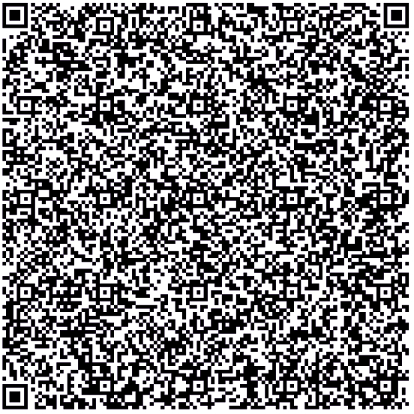

Note: In the absence of availability of proposer and seconded please send the following:

1. A photocopy of Degree
2. Photocopy of registration by relevant Medical Council
3. In case of non-medical member proposer and seconded are essential.

For Official Use

Membership No. Signature of Honorary Secretary